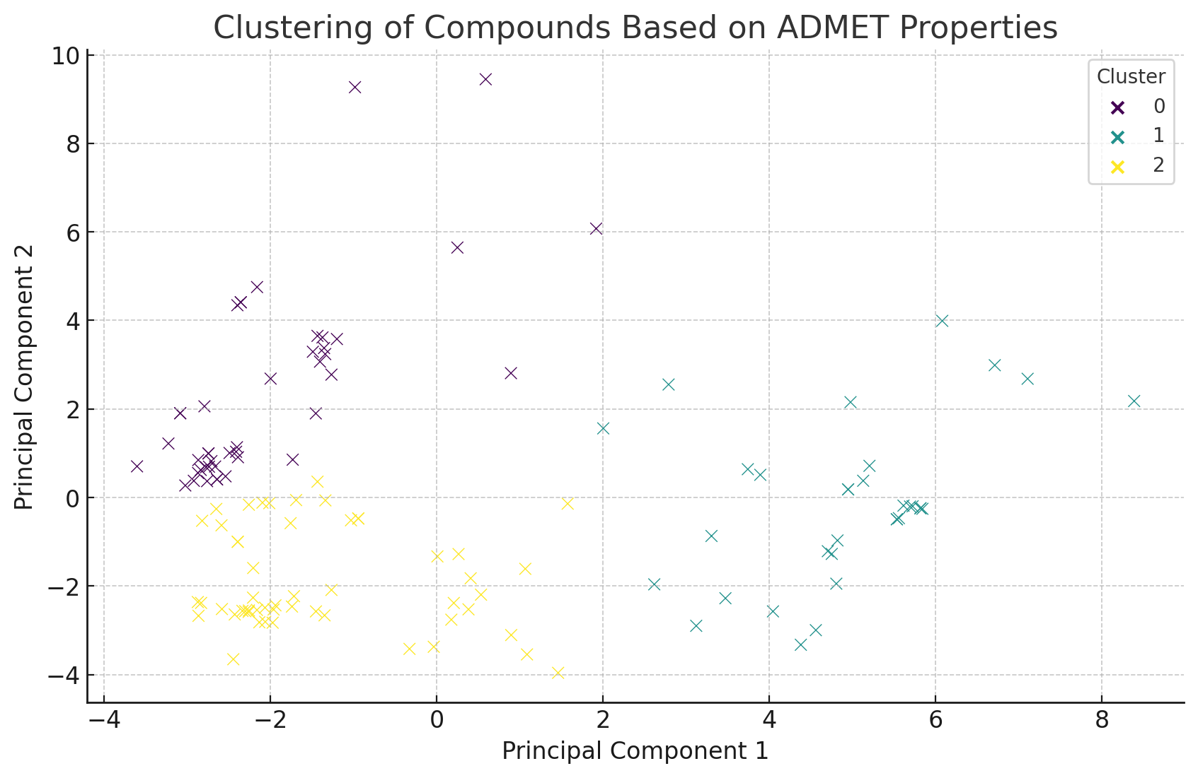

Figure S1: The results of PCA analysis of based on the ADMET properties of compounds.

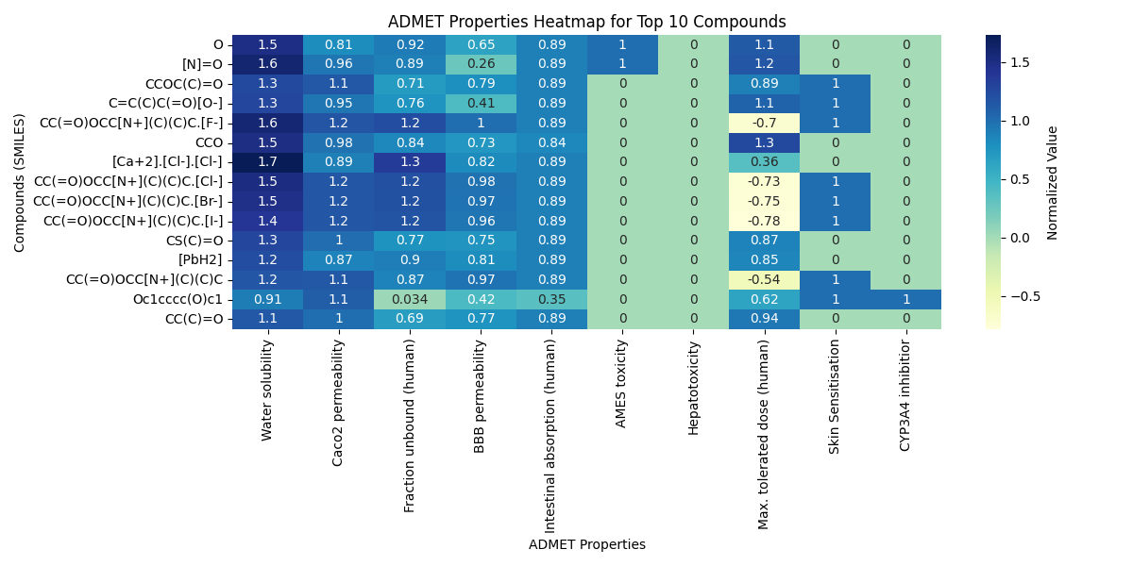

Figure S2: ADMET properties distribution for the best 15 compounds based on selective important wound healing properties.

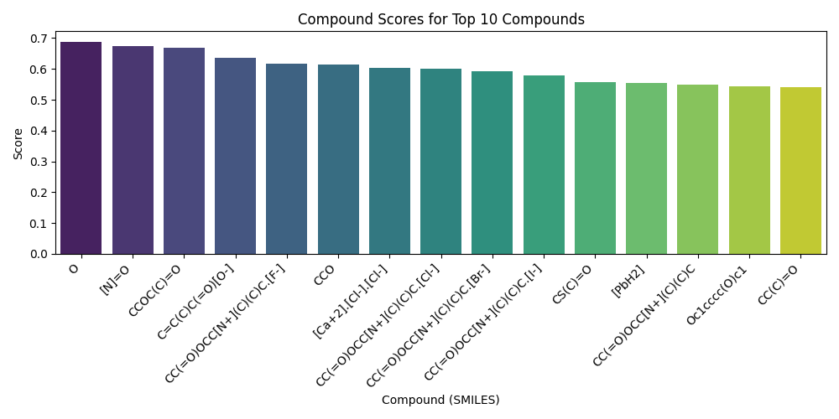

Figure S3: Score distribution for ADMET properties of the best 15 compounds.